Title: XXXXX
Author, Author, Author
Affiliation: xxx
Email: xxx@xx.xx.xx

Text, text......

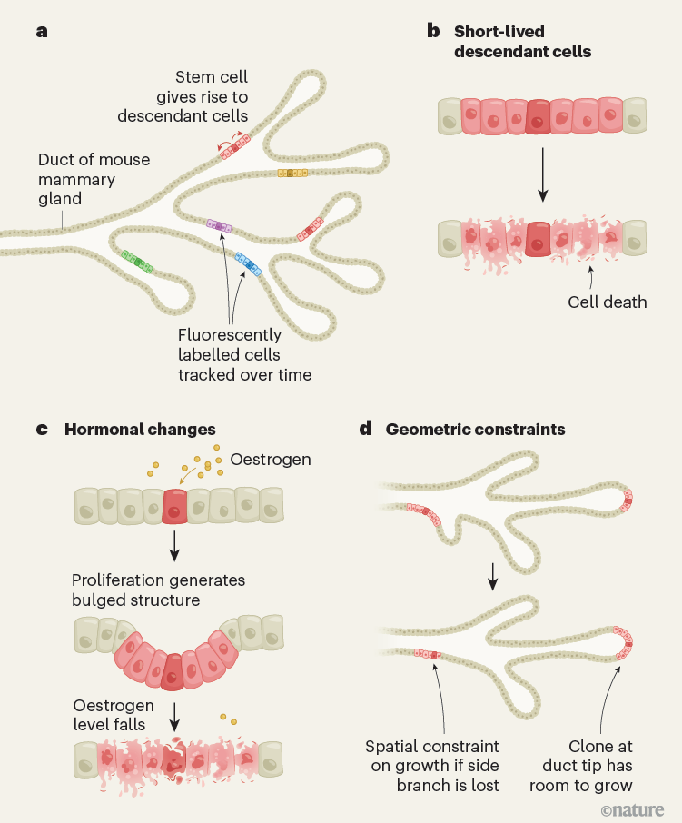
Fig 1. xxxxxxxxxx

Reference
[1] Jin, E.; Asada, M.; Xu, Q.; Dalapati, S.; Addicoat, M. A.; Brady, M. A.; Xu, H.; Nakamura, T.; Heine, T.; Chen, Q.; Jiang, D. Science 2017, 357, 673.
[2] Lin, X.; Wegner, B.; Lee, K. M.; Fusella, M. A.; Zhang, F.; Moudgil, K.; Rand, B. P.; Barlow, S.; Marder, S. R.; Koch, N.; Kahn, A. Nat. Mater. 2017, 16, 1209.

Biography
Text, text......

Format Requirements for Abstract
- Please control the length of the abstract within one page of the A4 paper. The top, bottom, left, and right margins are both 25 mm.
- The font for the entire text should be Times New Roman, except for the title, which is in size four, all other content should be in size five font.
- The molecular structure in the article is drawn using ChemDraw software, and it is recommended to use the ACS template for drawing.
- The reference follows the format of J The format of Am. Chem. Soc.
- Insert a clear personal identification photo in the part of the Biography.
- Please delete this page when submitting.

